WEEK 2 MANDATORY HANDSON

SUPERSET ID: 6410152

PL SQL: Exercise1:Control Structures:

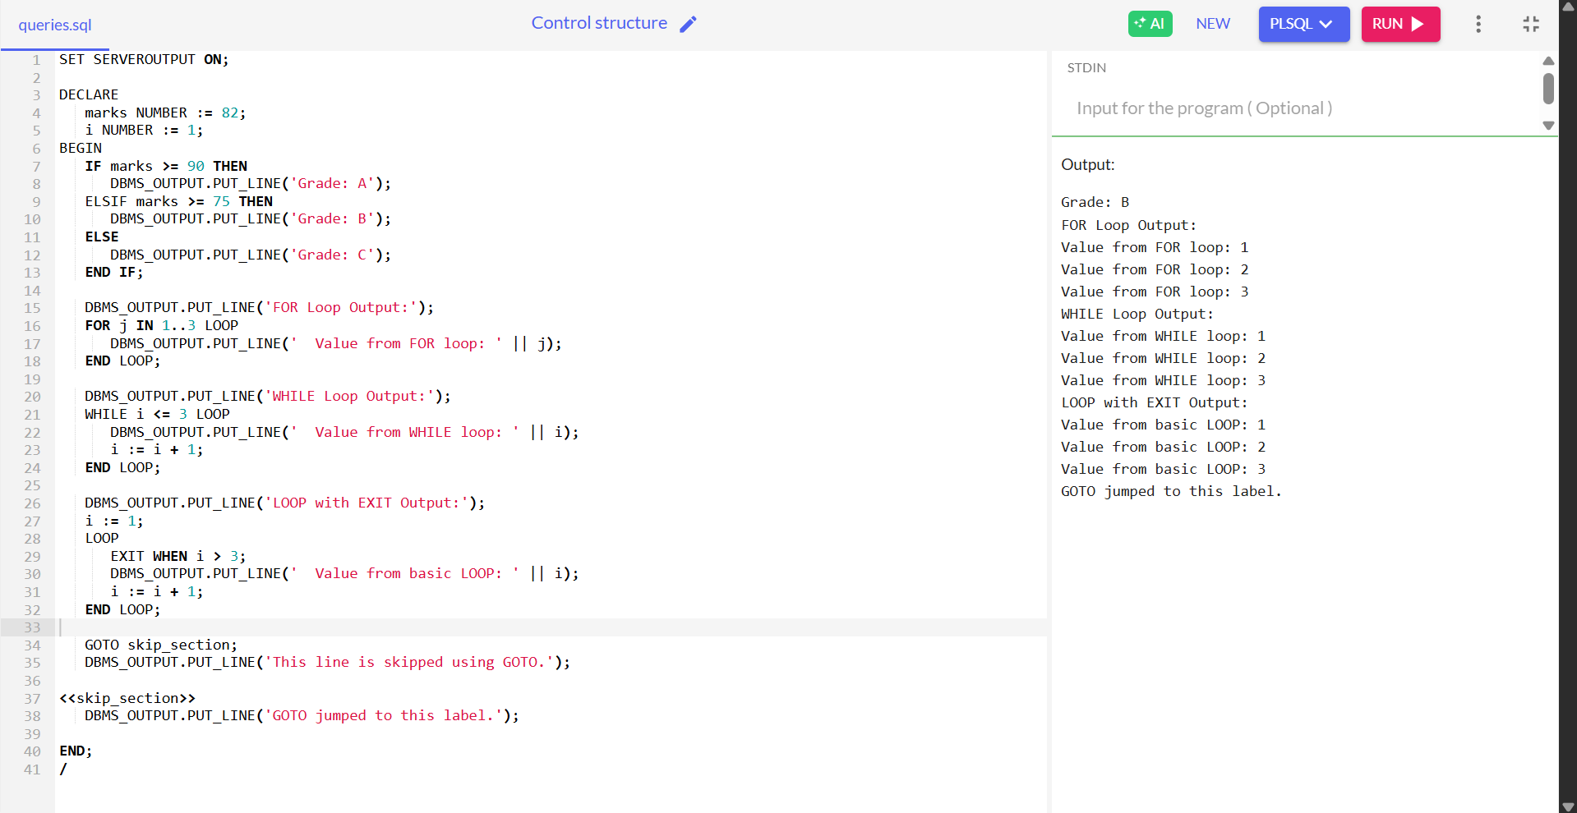

Exercise 3**:** Stored Procedures:

